**Screenshots of Chicken++ App**

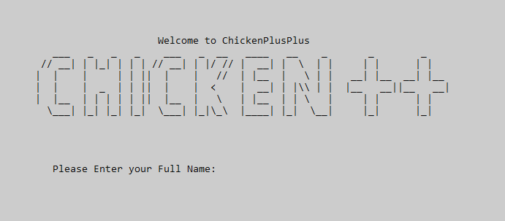

Figure 1. Welcome page of Chicken++ App

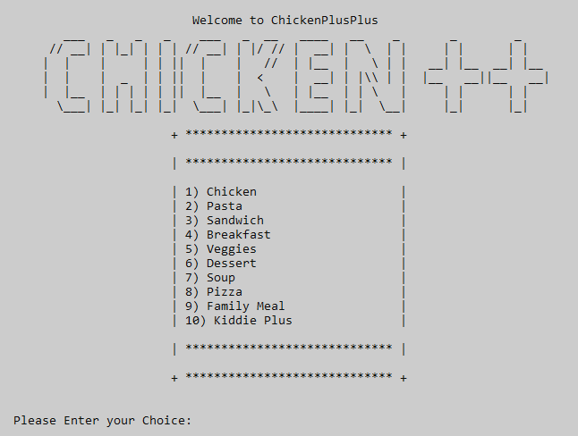

Figure 2. Menu list of Chicken++ App

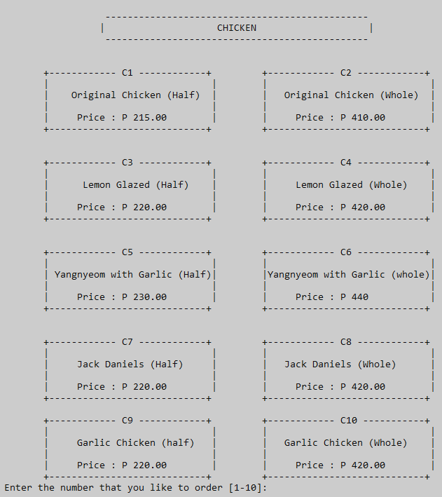

Figure 3. Chicken’s Menu list

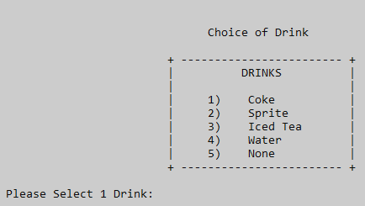

Figure 4. Drinks Menu

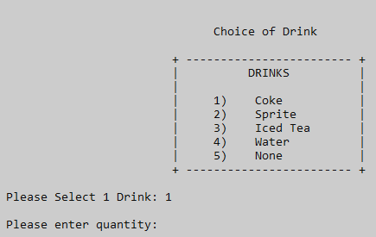

Figure 5. Enter quantity

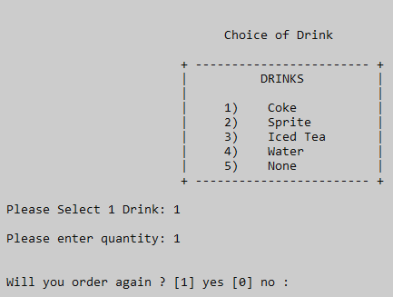

Figure 6. Order Again

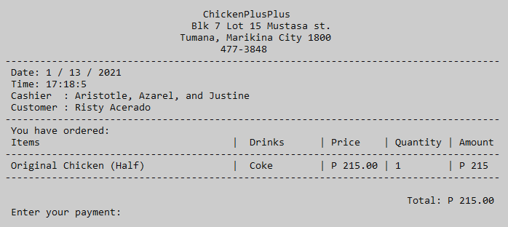

Figure 7. Total Bill

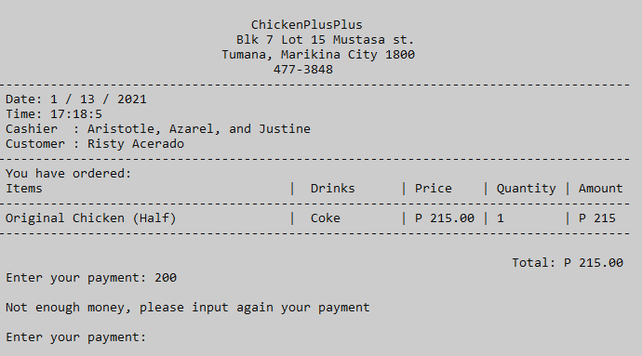

Figure 8. Enter payment

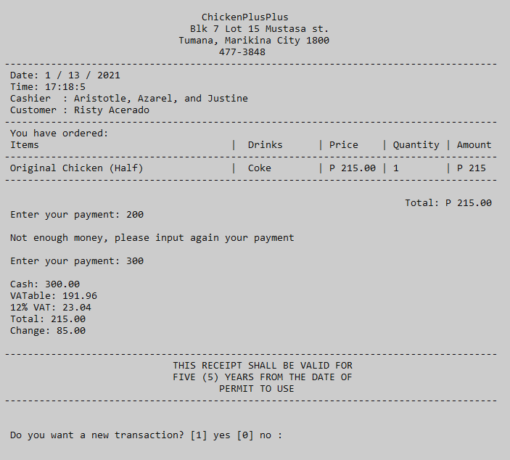

Figure 9. Final receipt

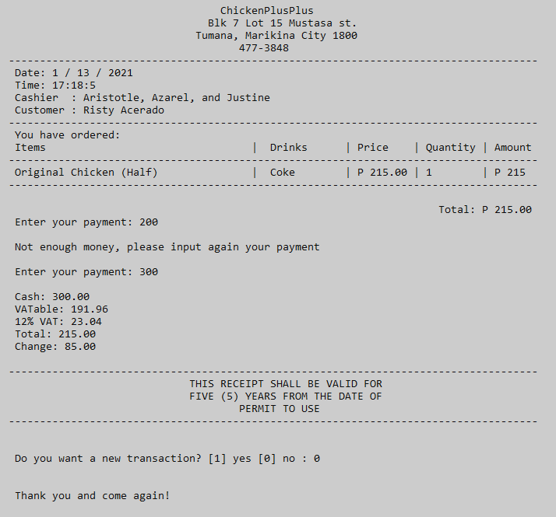

Figure 10. End of program

**Source code of Chicken++ App**

#include <iostream>

#include "windows.h" // sleep

#include <ctime> // time and date

#include <conio.h> // cls

#include <iomanip> //setprecision, setw

using namespace std;

void again (int& isExit);// Function Declaration

float bill(float& payment, float& change, float& vatAble, float& total, float& vat, int& newTransaction);

int drinksMenu(int& drinks);

void dots();

void display();

void blink(int);

void customer(string& user);

int menu(int& choice);

int code(int& ordercode);

int quants(int& quantity);

int main() {

// Variable Declaration

int choice;

int ordercode;

int drinks;

int quantity = 0;

int i=0;

string order[100];

string price[100];

string totalDrinks[100];

int totalQuantity[100];

int totalOrder[100];

int isExit=1;

int a;

string user;

time_t now = time(0);

tm *ltm = localtime(&now);

int max = 0;

float total = 0;

int pay = 0;

float payment = 0;

float change = 0;

float vat = 0;

float vatAble = 0;

int newTransaction;

system("COLOR 70"); // white background with color black font color

//This displays the Home screen of the program

display();

customer(user);

while ( isExit==1 ) {

max++; // increment

i++;

start:

system("CLS");

// The main menu of the program and where the customer can select their preferred meal

display();

menu(choice);

system("CLS");

// This is the menu when the customer has selected number 1 in the main menu

if(choice == 1)

{

chicken:

cout << "\n\t -----------------------------------------------"<<endl;

cout << "\t | CHICKEN |"<<endl;

cout << "\t -----------------------------------------------\n"<<endl;

cout << "\n +------------ C1 ------------+ \t +------------ C2 ------------+"<<endl;

cout << "\t| |\t | |" << endl;

cout << "\t| Original Chicken (Half) |\t | Original Chicken (Whole) |" << endl;

cout << "\t| |\t | |" << endl;

cout << "\t| Price : P 215.00 |\t | Price : P 410.00 |" << endl;

cout << "\t+----------------------------+\t +----------------------------+" << endl;

cout << "\n\n +------------ C3 ------------+ \t +------------ C4 ------------+"<<endl;

cout << "\t| |\t | |" << endl;

cout << "\t| Lemon Glazed (Half) |\t | Lemon Glazed (Whole) |" << endl;

cout << "\t| |\t | |" << endl;

cout << "\t| Price : P 220.00 |\t | Price : P 420.00 |" << endl;

cout << "\t+----------------------------+\t +----------------------------+" << endl;

cout << "\n\n +------------ C5 ------------+ \t +------------ C6 ------------+"<<endl;

cout << "\t| |\t | |"<<endl;

cout << "\t| Yangnyeom with Garlic (Half)|\t |Yangnyeom with Garlic (whole)|"<<endl;

cout << "\t| |\t | |"<<endl;

cout << "\t| Price : P 230.00 |\t | Price : P 440 |"<<endl;

cout << "\t+----------------------------+\t +----------------------------+"<<endl;

cout << "\n\n +------------ C7 ------------+ \t +------------ C8 ------------+"<<endl;

cout << "\t| |\t | |"<<endl;

cout << "\t| Jack Daniels (Half) |\t | Jack Daniels (Whole) |"<<endl;

cout << "\t| |\t | |"<<endl;

cout << "\t| Price : P 220.00 |\t | Price : P 420.00 |"<<endl;

cout << "\t+----------------------------+\t +----------------------------+"<<endl;

cout << "\n +------------ C9 ------------+ \t +------------ C10 -----------+"<<endl;

cout << "\t| |\t | |" << endl;

cout << "\t| Garlic Chicken (half) |\t | Garlic Chicken (Whole) |" << endl;

cout << "\t| |\t | |" << endl;

cout << "\t| Price : P 220.00 |\t | Price : P 420.00 |" << endl;

cout << "\t+----------------------------+\t +----------------------------+" << endl;

code(ordercode);

system("CLS");

// Drinks menu after the customer has selected chicken

drinksChicken:

system("CLS");

if (ordercode == 1 || ordercode == 2 || ordercode == 3 || ordercode == 4 || ordercode == 5 || ordercode == 6 || ordercode == 7 || ordercode == 8 || ordercode == 9 || ordercode == 10)

{

drinksMenu(drinks);

switch(drinks)

{

case 1:

totalDrinks [i] =" Coke ";

break;

case 2:

totalDrinks [i] =" Sprite ";

break;

case 3:

totalDrinks [i] =" Iced Tea ";

break;

case 4:

totalDrinks [i] =" Water ";

break;

case 5:

totalDrinks [i] =" None ";

break;

default:

goto drinksChicken;

break;

}

quants(quantity);

switch(ordercode)

{

case 1:

order[i] = "Original Chicken (Half)";

price[i] = "P 215.00";

totalQuantity[i] = quantity;

totalOrder[i] = 215*quantity;

break;

case 2:

order[i] = "Original Chicken (Whole)";

price[i] = "P 410.00";

totalQuantity[i] = quantity;

totalOrder[i] = 410*quantity;

break;

case 3:

order[i] = "Lemon Glazed (Half)";

price[i] = "P 220.00";

totalQuantity[i] = quantity;

totalOrder[i] = 220*quantity;

break;

case 4:

order[i] = "Lemon Glazed (Whole)";

price[i] = "P 420.00";

totalQuantity[i] = quantity;

totalOrder[i] = 420*quantity;

break;

case 5:

order[i] = "Yangnyeom with Garlic (Half)";

price[i] = "P 230.00";

totalQuantity[i] = quantity;

totalOrder[i] = 230*quantity;

break;

case 6:

order[i] = "Yangnyeom with Garlic (whole)";

price[i] = "P 440.00";

totalQuantity[i] = quantity;

totalOrder[i] = 440*quantity;

break;

case 7:

order[i] = "Jack Daniels (Half)";

price[i] = "P 220.00";

totalQuantity[i] = 220;

totalOrder[i] = 220*quantity;

break;

case 8:

order[i] = "Jack Daniels (Whole)";

price[i] = "P 420.00";

totalQuantity[i] = quantity;

totalOrder[i] = 420*quantity;

break;

case 9:

order[i] = "Garlic Chicken (half)";

price[i] = "P 220.00";

totalQuantity[i] = quantity;

totalOrder[i] = 220*quantity;

break;

case 10:

order[i] = "Garlic Chicken (whole)";

price[i] = "P 220.00";

totalQuantity[i] = quantity;

totalOrder[i] = 420*quantity;

break;

}

} else {

goto chicken;

}

// This is the menu when the customer has selected number 2 in the main menu

} else if (choice == 2)

{

pasta:

cout << "\n\t -----------------------------------------------"<<endl;

cout << "\t | PASTA |"<<endl;

cout << "\t -----------------------------------------------\n"<<endl;

cout << "\n +------------ P1 ------------+ \t +------------ P2 ------------+"<<endl;

cout << "\t| |\t | |" << endl;

cout << "\t| Spaghetti Bolognese |\t | Spaghetti Bolognese |" << endl;

cout << "\t| |\t | with Meatballs |" << endl;

cout << "\t| Price : P 119.00 |\t | Price : P 169.00 |" << endl;

cout << "\t+----------------------------+\t +----------------------------+" << endl;

cout << "\n\n +------------ P3 ------------+ \t +------------ P4 ------------+"<<endl;

cout << "\t| |\t | |" << endl;

cout << "\t| Spaghetti Carbonara |\t | Lasagna Classico |" << endl;

cout << "\t| |\t | |" << endl;

cout << "\t| Price : P 129.00 |\t | Price : P 189.00 |" << endl;

cout << "\t+----------------------------+\t +----------------------------+" << endl;

cout << "\n\n +------------ P5 ------------+ \t +------------ P6 ------------+"<<endl;

cout << "\t| |\t | |"<<endl;

cout << "\t| Bacon Aglio Olio |\t | Bacon Mac and Cheese |"<<endl;

cout << "\t| |\t | |"<<endl;

cout << "\t| Price : P 145.00 |\t | Price : P 169.00 |"<<endl;

cout << "\t+----------------------------+\t +----------------------------+"<<endl;

cout << "\n\n +------------ P7 ------------+ \t +------------ P8 ------------+"<<endl;

cout << "\t| |\t | |"<<endl;

cout << "\t| Fettucine Alfredo |\t | Fetucine a la king |"<<endl;

cout << "\t| |\t | |"<<endl;

cout << "\t| Price : P 149.00 |\t | Price : P 179.00 |"<<endl;

cout << "\t+----------------------------+\t +----------------------------+"<<endl;

cout << "\n +------------ P9 ------------+ \t +------------ P10 -----------+"<<endl;

cout << "\t| |\t | |" << endl;

cout << "\t| Pesto Chicken Penne |\t | Chicken Pops Mac and Cheese |" << endl;

cout << "\t| |\t | |" << endl;

cout << "\t| Price : P 189.00 |\t | Price : P 189.00 |" << endl;

cout << "\t+----------------------------+\t +----------------------------+" << endl;

code(ordercode);

system("CLS");

// Drinks menu after the customer has selected pasta

drinksPasta:

system("CLS");

if (ordercode == 1 || ordercode == 2 || ordercode == 3 || ordercode == 4 || ordercode == 5 || ordercode == 6 || ordercode == 7 || ordercode == 8 || ordercode == 9 || ordercode == 10)

{

drinksMenu(drinks);

switch(drinks)

{

case 1:

totalDrinks [i] =" Coke ";

break;

case 2:

totalDrinks [i] =" Sprite ";

break;

case 3:

totalDrinks [i] =" Iced Tea ";

break;

case 4:

totalDrinks [i] =" Water ";

break;

case 5:

totalDrinks [i] =" None ";

break;

default:

goto drinksPasta;

break;

}

quants(quantity);

switch(ordercode) {

case 1:

order[i] = "Spaghetti Bolognese";

price[i] = "P 119.00";

totalQuantity[i] = quantity;

totalOrder[i] = 119*quantity;

break;

case 2:

order[i] = "Spaghetti Bolognese with Meatballs";

price[i] = "P 169.00";

totalQuantity[i] = quantity;

totalOrder[i] = 169*quantity;

break;

case 3:

order[i] = "Spaghetti Carbonara";

price[i] = "P 129.00";

totalQuantity[i] = quantity;

totalOrder[i] = 129*quantity;

break;

case 4:

order[i] = "Lasagna Classico";

price[i] = "P 189.00";

totalQuantity[i] = quantity;

totalOrder[i] = 189*quantity;

break;

case 5:

order[i] = "Bacon Aglio Olio";

price[i] = "P 145.00";

totalQuantity[i] = quantity;

totalOrder[i] = 145*quantity;

break;

case 6:

order[i] = "Bacon Mac and Cheese ";

price[i] = "P 169.00";

totalQuantity[i] = quantity;

totalOrder[i] = 169*quantity;

break;

case 7:

order[i] = "Fettucine Alfredo";

price[i] = "P 149.00";

totalQuantity[i] = quantity;

totalOrder[i] = 149*quantity;

break;

case 8:

order[i] = "Fetucine a la king";

price[i] = "P 179.00";

totalQuantity[i] = quantity;

totalOrder[i] = 179*quantity;

break;

case 9:

order[i] = "Pesto Chicken Penne";

price[i] = "P 189.00";

totalQuantity[i] = quantity;

totalOrder[i] = 189*quantity;

break;

case 10:

order[i] = "Chicken Pops Mac and Cheese";

price[i] = "P 189.00";

totalQuantity[i] = quantity;

totalOrder[i] = 189*quantity;

break;

}

} else {

goto pasta;

}

// This is the menu when the customer has selected number 3 in the main menu

} else if (choice == 3)

{

sandwich:

cout << "\n\t -----------------------------------------------"<<endl;

cout << "\t | SANDWICH |"<<endl;

cout << "\t -----------------------------------------------\n"<<endl;

cout << "\n +------------ S1 ------------+ \t +------------ S2 ------------+"<<endl;

cout << "\t| |\t | |" << endl;

cout << "\t| Pesto Egg Roll |\t | Tuna Salad Roll |" << endl;

cout << "\t| |\t | |" << endl;

cout << "\t| Price : P 150.00 |\t | Price : P 169.00 |" << endl;

cout << "\t+----------------------------+\t +----------------------------+" << endl;

cout << "\n\n +------------ S3 ------------+ \t +------------ S4 ------------+"<<endl;

cout << "\t| |\t | |" << endl;

cout << "\t| Bacon Toastie |\t | Bacon and Egg Sandwich |" << endl;

cout << "\t| |\t | |" << endl;

cout << "\t| Price : P 175.00 |\t | Price : P 140.00 |" << endl;

cout << "\t+----------------------------+\t +----------------------------+" << endl;

cout << "\n\n +------------ S5 ------------+ \t +------------ S6 ------------+"<<endl;

cout << "\t| |\t | |"<<endl;

cout << "\t| Cheese and Pickle |\t | Mexican Chicken Special |"<<endl;

cout << "\t| |\t | |"<<endl;

cout << "\t| Price : P 175.00 |\t | Price : P 150.00 |"<<endl;

cout << "\t+----------------------------+\t +----------------------------+"<<endl;

cout << "\n\n +------------ S7 ------------+ \t +------------ S8 ------------+"<<endl;

cout << "\t| |\t | |"<<endl;

cout << "\t| Ham and Cheese Croissant |\t | Crispy Bacon and Avocado |"<<endl;

cout << "\t| |\t | |"<<endl;

cout << "\t| Price : P 140.00 |\t | Price : P 175.00 |"<<endl;

cout << "\t+----------------------------+\t +----------------------------+"<<endl;

cout << "\n +------------ S9 ------------+ \t +------------ S10 -----------+"<<endl;

cout << "\t| |\t | |" << endl;

cout << "\t| Brie and Ham |\t | Salami and Cornedbeef |" << endl;

cout << "\t| |\t | |" << endl;

cout << "\t| Price : P 140.00 |\t | Price : P 160.00 |" << endl;

cout << "\t+----------------------------+\t +----------------------------+" << endl;

code(ordercode);

system("CLS");

// Drinks menu after the customer has selected sandwich

drinksSandwich:

system("CLS");

if (ordercode == 1 || ordercode == 2 || ordercode == 3 || ordercode == 4 || ordercode == 5 || ordercode == 6 || ordercode == 7 || ordercode == 8 || ordercode == 9 || ordercode == 10)

{

drinksMenu(drinks);

switch(drinks)

{

case 1:

totalDrinks [i] =" Coke ";

break;

case 2:

totalDrinks [i] =" Sprite ";

break;

case 3:

totalDrinks [i] =" Iced Tea ";

break;

case 4:

totalDrinks [i] =" Water ";

break;

case 5:

totalDrinks [i] =" None ";

break;

default:

goto drinksSandwich;

break;

}

quants(quantity);

switch(ordercode) {

case 1:

order[i] = "Pesto Egg Roll";

price[i] = "P 150.00";

totalQuantity[i] = quantity;

totalOrder[i] = 150*quantity;

break;

case 2:

order[i] = "Tuna Salad Roll ";

price[i] = "P 169.00";

totalQuantity[i] = quantity;

totalOrder[i] = 169*quantity;

break;

case 3:

order[i] = "Bacon Toastie";

price[i] = "P 175.00";

totalQuantity[i] = quantity;

totalOrder[i] = 175*quantity;

break;

case 4:

order[i] = "Bacon and Egg Sandwich";

price[i] = "P 140.00";

totalQuantity[i] = quantity;

totalOrder[i] = 140*quantity;

break;

case 5:

order[i] = "Cheese and Pickle";

price[i] = "P 175.00";

totalQuantity[i] = quantity;

totalOrder[i] = 175*quantity;

break;

case 6:

order[i] = "Mexican Chicken Special";

price[i] = "P 150.00";

totalQuantity[i] = quantity;

totalOrder[i] = 150*quantity;

break;

case 7:

order[i] = "Ham and Cheese Croissant";

price[i] = "P 140.00";

totalQuantity[i] = quantity;

totalOrder[i] = 140*quantity;

break;

case 8:

order[i] = "Crispy Bacon and Avocado";

price[i] = "P 175.00";

totalQuantity[i] = quantity;

totalOrder[i] = 175*quantity;

break;

case 9:

order[i] = "Brie and Ham";

price[i] = "P 140.00";

totalQuantity[i] = quantity;

totalOrder[i] = 140*quantity;

break;

case 10:

order[i] = "Salami and Cornedbeef";

price[i] = "P 160.00";

totalQuantity[i] = quantity;

totalOrder[i] = 160*quantity;

break;

}

} else {

goto sandwich;

}

// This is the menu when the customer has selected number 4 in the main menu

} else if (choice == 4)

{

breakfast:

cout << "\n\t -----------------------------------------------"<<endl;

cout << "\t | BREAKFAST |"<<endl;

cout << "\t -----------------------------------------------\n"<<endl;

cout << "\n +------------ B1 ------------+ \t +------------ B2 ------------+"<<endl;

cout << "\t| |\t | |" << endl;

cout << "\t| Sausage and Egg Muffin |\t | Arroz caldo |" << endl;

cout << "\t| |\t | |" << endl;

cout << "\t| Price : P 240.00 |\t | Price : P 100.00 |" << endl;

cout << "\t+----------------------------+\t +----------------------------+" << endl;

cout << "\n\n +------------ B3 ------------+ \t +------------ B4 ------------+"<<endl;

cout << "\t| |\t | |" << endl;

cout << "\t| Chicken and Waffle |\t | Tapa Steak |" << endl;

cout << "\t| |\t | |" << endl;

cout << "\t| Price : P 280.00 |\t | Price : P 290.00 |" << endl;

cout << "\t+----------------------------+\t +----------------------------+" << endl;

cout << "\n\n +------------ B5 ------------+ \t +------------ B6 ------------+"<<endl;

cout << "\t| |\t | |"<<endl;

cout << "\t| Chixilog |\t | Mexican Omellete |"<<endl;

cout << "\t| |\t | |"<<endl;

cout << "\t| Price : P 200.00 |\t | Price : P 280.00 |"<<endl;

cout << "\t+----------------------------+\t +----------------------------+"<<endl;

cout << "\n\n +------------ B7 ------------+ \t +------------ B8 ------------+"<<endl;

cout << "\t| |\t | |"<<endl;

cout << "\t| Steak and Eggs |\t | Spamsilog |"<<endl;

cout << "\t| |\t | |"<<endl;

cout << "\t| Price : P 340.00 |\t | Price : P 190.00 |"<<endl;

cout << "\t+----------------------------+\t +----------------------------+"<<endl;

cout << "\n +------------ B9 ------------+ \t +------------ B10 -----------+"<<endl;

cout << "\t| |\t | |" << endl;

cout << "\t| Bacon and Eggs |\t | Eggs and French Toast |" << endl;

cout << "\t| |\t | |" << endl;

cout << "\t| Price : P 230.00 |\t | Price : P 150.00 |" << endl;

cout << "\t+----------------------------+\t +----------------------------+" << endl;

code(ordercode);

system("CLS");

// Drinks menu after the customer has selected breakfast

drinksBreakfast:

system("CLS");

if (ordercode == 1 || ordercode == 2 || ordercode == 3 || ordercode == 4 || ordercode == 5 || ordercode == 6 || ordercode == 7 || ordercode == 8 || ordercode == 9 || ordercode == 10)

{

drinksMenu(drinks);

switch(drinks)

{

case 1:

totalDrinks [i] =" Coke ";

break;

case 2:

totalDrinks [i] =" Sprite ";

break;

case 3:

totalDrinks [i] =" Iced Tea ";

break;

case 4:

totalDrinks [i] =" Water ";

break;

case 5:

totalDrinks [i] =" None ";

break;

default:

goto drinksBreakfast;

break;

}

quants(quantity);

switch(ordercode) {

case 1:

order[i] = "Sausage and Egg Muffin";

price[i] = "P 240.00";

totalQuantity[i] = quantity;

totalOrder[i] = 240*quantity;

break;

case 2:

order[i] = "Arroz caldo";

price[i] = "P 100.00";

totalQuantity[i] = quantity;

totalOrder[i] = 100*quantity;

break;

case 3:

order[i] = "Chicken and Waffle";

price[i] = "P 280.00";

totalQuantity[i] = quantity;

totalOrder[i] = 280*quantity;

break;

case 4:

order[i] = "Tapa Steak";

price[i] = "P 290.00";

totalQuantity[i] = quantity;

totalOrder[i] = 290*quantity;

break;

case 5:

order[i] = "Chixilog";

price[i] = "P 200.00";

totalQuantity[i] = quantity;

totalOrder[i] = 200*quantity;

break;

case 6:

order[i] = "Mexican Omellete";

price[i] = "P 280.00";

totalQuantity[i] = quantity;

totalOrder[i] = 280*quantity;

break;

case 7:

order[i] = "Steak and Eggs";

price[i] = "P 270.00";

totalQuantity[i] = quantity;

totalOrder[i] = 270*quantity;

break;

case 8:

order[i] = "Spamsilog";

price[i] = "P 190.00";

totalQuantity[i] = quantity;

totalOrder[i] = 190*quantity;

break;

case 9:

order[i] = "Bacon and Eggs";

price[i] = "P 230.00";

totalQuantity[i] = quantity;

totalOrder[i] = 230*quantity;

break;

case 10:

order[i] = "Eggs and French Toast";

price[i] = "P 150.00";

totalQuantity[i] = quantity;

totalOrder[i] = 150*quantity;

break;

}

} else {

goto breakfast;

}

// This is the menu when the customer has selected number 5 in the main menu

} else if (choice == 5)

{

veggies:

cout << "\n\t -----------------------------------------------"<<endl;

cout << "\t | VEGGIES |"<<endl;

cout << "\t -----------------------------------------------\n"<<endl;

cout << "\n +------------ V1 ------------+ \t +------------ V2 ------------+"<<endl;

cout << "\t| |\t | |" << endl;

cout << "\t| Mango salad |\t | Buttered Veggies (special) |" << endl;

cout << "\t| |\t | |" << endl;

cout << "\t| Price : P 120.00 |\t | Price : P 150.00 |" << endl;

cout << "\t+----------------------------+\t +----------------------------+" << endl;

cout << "\n\n +------------ V3 ------------+ \t +------------ V4 ------------+"<<endl;

cout << "\t| |\t | |" << endl;

cout << "\t| Buttered Veggies |\t | Chopsuey |" << endl;

cout << "\t| |\t | |" << endl;

cout << "\t| Price : P 80.00 |\t | Price : P 140.00 |" << endl;

cout << "\t+----------------------------+\t +----------------------------+" << endl;

cout << "\n\n +------------ V5 ------------+ \t +------------ V6 ------------+"<<endl;

cout << "\t| |\t | |"<<endl;

cout << "\t| Grilled Eggplant Salad |\t | Spicy Garlic Kangkong |"<<endl;

cout << "\t| |\t | |"<<endl;

cout << "\t| Price : P 120.00 |\t | Price : P 140.00 |"<<endl;

cout << "\t+----------------------------+\t +----------------------------+"<<endl;

cout << "\n\n +------------ V7 ------------+ \t +------------ V8 ------------+"<<endl;

cout << "\t| |\t | |"<<endl;

cout << "\t| Cucumber and Tomato Salad |\t | Pechay Guisado |"<<endl;

cout << "\t| |\t | |"<<endl;

cout << "\t| Price : P 100.00 |\t | Price : P 120.00 |"<<endl;

cout << "\t+----------------------------+\t +----------------------------+"<<endl;

cout << "\n +------------ V9 ------------+ \t +------------ V10 -----------+"<<endl;

cout << "\t| |\t | |" << endl;

cout << "\t| Tofu Salad |\t | Ampalaya Guisado with Egg |" << endl;

cout << "\t| |\t | |" << endl;

cout << "\t| Price : P 120.00 |\t | Price : P 150.00 |" << endl;

cout << "\t+----------------------------+\t +----------------------------+" << endl;

code(ordercode);

system("CLS");

// Drinks menu after the customer has selected veggies

drinksVeggies:

system("CLS");

if (ordercode == 1 || ordercode == 2 || ordercode == 3 || ordercode == 4 || ordercode == 5 || ordercode == 6 || ordercode == 7 || ordercode == 8 || ordercode == 9 || ordercode == 10)

{

drinksMenu(drinks);

switch(drinks)

{

case 1:

totalDrinks [i] =" Coke ";

break;

case 2:

totalDrinks [i] =" Sprite ";

break;

case 3:

totalDrinks [i] =" Iced Tea ";

break;

case 4:

totalDrinks [i] =" Water ";

break;

case 5:

totalDrinks [i] =" None ";

break;

default:

goto drinksVeggies;

break;

}

quants(quantity);

switch(ordercode) {

case 1:

order[i] = "Mango salad ";

price[i] = "P 120.00";

totalQuantity[i] = quantity;

totalOrder[i] = 120*quantity;

break;

case 2:

order[i] = "Buttered Veggies (special)";

price[i] = "P 150.00";

totalQuantity[i] = quantity;

totalOrder[i] = 150*quantity;

break;

case 3:

order[i] = "Buttered Veggies ";

price[i] = "P 80.00";

totalQuantity[i] = quantity;

totalOrder[i] = 80*quantity;

break;

case 4:

order[i] = "Chopsuey";

price[i] = "P 140.00";

totalQuantity[i] = quantity;

totalOrder[i] = 140*quantity;

break;

case 5:

order[i] = "Grilled Eggplant Salad";

price[i] = "P 120.00";

totalQuantity[i] = quantity;

totalOrder[i] = 120*quantity;

break;

case 6:

order[i] = "Spicy Garlic Kangkong";

price[i] = "P 140.00";

totalQuantity[i] = quantity;

totalOrder[i] = 140*quantity;

break;

case 7:

order[i] = "Cucumber and Tomato Salad";

price[i] = "P 100.00";

totalQuantity[i] = quantity;

totalOrder[i] = 100*quantity;

break;

case 8:

order[i] = "Pechay Guisado";

price[i] = "P 120.00";

totalQuantity[i] = quantity;

totalOrder[i] = 120*quantity;

break;

case 9:

order[i] = "Tofu Salad";

price[i] = "P 120.00";

totalQuantity[i] = quantity;

totalOrder[i] = 120*quantity;

break;

case 10:

order[i] = "Ampalaya Guisado with Egg";

price[i] = "P 150.00";

totalQuantity[i] = quantity;

totalOrder[i] = 150*quantity;

break;

}

} else {

goto veggies;

}

// This is the menu when the customer has selected number 6 in the main menu

} else if (choice == 6)

{

dessert:

cout << "\n\t -----------------------------------------------"<<endl;

cout << "\t | DESSERT |"<<endl;

cout << "\t -----------------------------------------------\n"<<endl;

cout << "\n +------------ V1 ------------+ \t +------------ V2 ------------+"<<endl;

cout << "\t| |\t | |" << endl;

cout << "\t| Macha Lava |\t | French Gelato |" << endl;

cout << "\t| |\t | |" << endl;

cout << "\t| Price : P 180.00 |\t | Price : P 200.00 |" << endl;

cout << "\t+----------------------------+\t +----------------------------+" << endl;

cout << "\n\n +------------ V3 ------------+ \t +------------ V4 ------------+"<<endl;

cout << "\t| |\t | |" << endl;

cout << "\t| Golden Toast |\t | Triple Layer Cake |" << endl;

cout << "\t| |\t | |" << endl;

cout << "\t| Price : P 150.00 |\t | Price : P 200.00 |" << endl;

cout << "\t+----------------------------+\t +----------------------------+" << endl;

cout << "\n\n +------------ V5 ------------+ \t +------------ V6 ------------+"<<endl;

cout << "\t| |\t | |"<<endl;

cout << "\t| Miso Butterscotch |\t | Apple Fritters |"<<endl;

cout << "\t| |\t | |"<<endl;

cout << "\t| Price : P 150.00 |\t | Price : P 250.00 |"<<endl;

cout << "\t+----------------------------+\t +----------------------------+"<<endl;

cout << "\n\n +------------ V7 ------------+ \t +------------ V8 ------------+"<<endl;

cout << "\t| |\t | |"<<endl;

cout << "\t| Cheese Cake |\t | Dessert Sampler |"<<endl;

cout << "\t| |\t | |"<<endl;

cout << "\t| Price : P 100.00 |\t | Price : P 220.00 |"<<endl;

cout << "\t+----------------------------+\t +----------------------------+"<<endl;

cout << "\n +------------ V9 ------------+ \t +------------ V10 -----------+"<<endl;

cout << "\t| |\t | |" << endl;

cout << "\t| Tiramisu |\t | Assorted Cupcakes |" << endl;

cout << "\t| |\t | |" << endl;

cout << "\t| Price : P 180.00 |\t | Price : P 180.00 |" << endl;

cout << "\t+----------------------------+\t +----------------------------+" << endl;

code(ordercode);

system("CLS");

// Drinks menu after the customer has selected dessert

drinksDessert:

system("CLS");

if (ordercode == 1 || ordercode == 2 || ordercode == 3 || ordercode == 4 || ordercode == 5 || ordercode == 6 || ordercode == 7 || ordercode == 8 || ordercode == 9 || ordercode == 10)

{

drinksMenu(drinks);

switch(drinks)

{

case 1:

totalDrinks [i] =" Coke ";

break;

case 2:

totalDrinks [i] =" Sprite ";

break;

case 3:

totalDrinks [i] =" Iced Tea ";

break;

case 4:

totalDrinks [i] =" Water ";

break;

case 5:

totalDrinks [i] =" None ";

break;

default:

goto drinksDessert;

break;

}

quants(quantity);

switch(ordercode) {

case 1:

order[i] = "Macha Lava";

price[i] = "P 180.00";

totalQuantity[i] = quantity;

totalOrder[i] = 180*quantity;

break;

case 2:

order[i] = "French Gelato";

price[i] = "P 200.00";

totalQuantity[i] = quantity;

totalOrder[i] = 200*quantity;

break;

case 3:

order[i] = "Golden Toast";

price[i] = "P 150.00";

totalQuantity[i] = quantity;

totalOrder[i] = 150*quantity;

break;

case 4:

order[i] = "Triple Layer Cake";

price[i] = "P 200.00";

totalQuantity[i] = quantity;

totalOrder[i] = 200*quantity;

break;

case 5:

order[i] = "Miso Butterscotch";

price[i] = "P 150.00";

totalQuantity[i] = quantity;

totalOrder[i] = 150*quantity;

break;

case 6:

order[i] = "Apple Fritters";

price[i] = "P 250.00";

totalQuantity[i] = quantity;

totalOrder[i] = 250*quantity;

break;

case 7:

order[i] = "Cheese Cake";

price[i] = "P 100.00";

totalQuantity[i] = quantity;

totalOrder[i] = 100*quantity;

break;

case 8:

order[i] = "Dessert Sampler";

price[i] = "P 220.00";

totalQuantity[i] = quantity;

totalOrder[i] = 220*quantity;

break;

case 9:

order[i] = "Tiramisu";

price[i] = "P 180.00";

totalQuantity[i] = quantity;

totalOrder[i] = 180*quantity;

break;

case 10:

order[i] = "Assorted Cupcakes";

price[i] = "P 180.00";

totalQuantity[i] = quantity;

totalOrder[i] = 180*quantity;

break;

}

} else {

goto dessert;

}

// This is the menu when the customer has selected number 7 in the main menu

} else if (choice == 7)

{

soup:

cout << "\n\t -----------------------------------------------"<<endl;

cout << "\t | SOUP |"<<endl;

cout << "\t -----------------------------------------------\n"<<endl;

cout << "\n +------------ S1 ------------+ \t +------------ S2 ------------+"<<endl;

cout << "\t| |\t | |" << endl;

cout << "\t| Chicken Afritada |\t | Chicken Corn Soup |" << endl;

cout << "\t| |\t | |" << endl;

cout << "\t| Price : P 140.00 |\t | Price : P 120.00 |" << endl;

cout << "\t+----------------------------+\t +----------------------------+" << endl;

cout << "\n\n +------------ S3 ------------+ \t +------------ S4 ------------+"<<endl;

cout << "\t| |\t | |" << endl;

cout << "\t| Crab and Corn soup |\t | Chicken Asparagus Soup |" << endl;

cout << "\t| |\t | |" << endl;

cout << "\t| Price : P 150.00 |\t | Price : P 180.00 |" << endl;

cout << "\t+----------------------------+\t +----------------------------+" << endl;

cout << "\n\n +------------ S5 ------------+ \t +------------ S6 ------------+"<<endl;

cout << "\t| |\t | |"<<endl;

cout << "\t| Chicken Mami |\t | Beef Pares |"<<endl;

cout << "\t| |\t | |"<<endl;

cout << "\t| Price : P 100.00 |\t | Price : P 110.00 |"<<endl;

cout << "\t+----------------------------+\t +----------------------------+"<<endl;

cout << "\n\n +------------ S7 ------------+ \t +------------ S8 ------------+"<<endl;

cout << "\t| |\t | |"<<endl;

cout << "\t| Creamy Chicken Sopas |\t | Beef Ribs Sinigang |"<<endl;

cout << "\t| |\t | |"<<endl;

cout << "\t| Price : P 130.00 |\t | Price : P 220.00 |"<<endl;

cout << "\t+----------------------------+\t +----------------------------+"<<endl;

cout << "\n +------------ S9 ------------+ \t +------------ S10 -----------+"<<endl;

cout << "\t| |\t | |" << endl;

cout << "\t| Boiled Beef Soup |\t | Manila Clam |" << endl;

cout << "\t| |\t | and Mussel Tinola |" << endl;

cout << "\t| Price : P 140.00 |\t | Price : P 170.00 |" << endl;

cout << "\t+----------------------------+\t +----------------------------+" << endl;

code(ordercode);

system("CLS");

// Drinks menu after the customer has selected soup

drinksSoup:

system("CLS");

if (ordercode == 1 || ordercode == 2 || ordercode == 3 || ordercode == 4 || ordercode == 5 || ordercode == 6 || ordercode == 7 || ordercode == 8 || ordercode == 9 || ordercode == 10)

{

drinksMenu(drinks);

switch(drinks)

{

case 1:

totalDrinks [i] =" Coke ";

break;

case 2:

totalDrinks [i] =" Sprite ";

break;

case 3:

totalDrinks [i] =" Iced Tea ";

break;

case 4:

totalDrinks [i] =" Water ";

break;

case 5:

totalDrinks [i] =" None ";

break;

default:

goto drinksSoup;

break;

}

quants(quantity);

switch(ordercode) {

case 1:

order[i] = "Chicken Afritada";

price[i] = "P 140.00";

totalQuantity[i] = quantity;

totalOrder[i] = 140*quantity;

break;

case 2:

order[i] = "Chicken Corn Soup";

price[i] = "P 120.00";

totalQuantity[i] = quantity;

totalOrder[i] = 120*quantity;

break;

case 3:

order[i] = "Crab and Corn soup";

price[i] = "P 150.00";

totalQuantity[i] = quantity;

totalOrder[i] = 150*quantity;

break;

case 4:

order[i] = "Chicken Asparagus Soup";

price[i] = "P 180.00";

totalQuantity[i] = quantity;

totalOrder[i] = 180*quantity;

break;

case 5:

order[i] = "Chicken Mami";

price[i] = "P 100.00";

totalQuantity[i] = quantity;

totalOrder[i] = 100*quantity;

break;

case 6:

order[i] = "Beef Pares";

price[i] = "P 110.00";

totalQuantity[i] = quantity;

totalOrder[i] = 110*quantity;

break;

case 7:

order[i] = "Creamy Chicken Sopas";

price[i] = "P 130.00";

totalQuantity[i] = quantity;

totalOrder[i] = 130*quantity;

break;

case 8:

order[i] = "Beef Ribs Sinigang";

price[i] = "P 220.00";

totalQuantity[i] = quantity;

totalOrder[i] = 220*quantity;

break;

case 9:

order[i] = "Boiled Beef Soup";

price[i] = "P 140.00";

totalQuantity[i] = quantity;

totalOrder[i] = 140*quantity;

break;

case 10:

order[i] = "Manila Clam and Mussel Tinola";

price[i] = "P 170.00";

totalQuantity[i] = quantity;

totalOrder[i] = 170*quantity;

break;

}

} else {

goto soup;

}

// This is the menu when the customer has selected number 8 in the main menu

} else if (choice == 8)

{

pizza:

cout << "\n\t -----------------------------------------------"<<endl;

cout << "\t | PIZZA |"<<endl;

cout << "\t -----------------------------------------------\n"<<endl;

cout << "\n +------------ Z1 ------------+ \t +------------ Z2 ------------+"<<endl;

cout << "\t| |\t | |" << endl;

cout << "\t| Original |\t | Pepperoni |" << endl;

cout << "\t| |\t | |" << endl;

cout << "\t| Price : P 115.00 |\t | Price : P 190.00 |" << endl;

cout << "\t+----------------------------+\t +----------------------------+" << endl;

cout << "\n\n +------------ Z3 ------------+ \t +------------ Z4 ------------+"<<endl;

cout << "\t| |\t | |" << endl;

cout << "\t| Tuna Fish |\t | Sausage |" << endl;

cout << "\t| |\t | |" << endl;

cout << "\t| Price : P 180.00 |\t | Price : P 180.00 |" << endl;

cout << "\t+----------------------------+\t +----------------------------+" << endl;

cout << "\n\n +------------ Z5 ------------+ \t +------------ Z6 ------------+"<<endl;

cout << "\t| |\t | |"<<endl;

cout << "\t| Bacon |\t | Mozzarella |"<<endl;

cout << "\t| |\t | |"<<endl;

cout << "\t| Price : P 160.00 |\t | Price : P 139.00 |"<<endl;

cout << "\t+----------------------------+\t +----------------------------+"<<endl;

cout << "\n\n +------------ Z7 ------------+ \t +------------ Z8 ------------+"<<endl;

cout << "\t| |\t | |"<<endl;

cout << "\t| Mushroom |\t | Peppers |"<<endl;

cout << "\t| |\t | |"<<endl;

cout << "\t| Price : P 180.00 |\t | Price : P 130.00 |"<<endl;

cout << "\t+----------------------------+\t +----------------------------+"<<endl;

cout << "\n +------------ Z9 ------------+ \t +------------ Z10 -----------+"<<endl;

cout << "\t| |\t | |" << endl;

cout << "\t| Onion |\t | Clams |" << endl;

cout << "\t| |\t | |" << endl;

cout << "\t| Price : P 130.00 |\t | Price : P 190.00 |" << endl;

cout << "\t+----------------------------+\t +----------------------------+" << endl;

code(ordercode);

system("CLS");

// Drinks menu after the customer has selected pizza

drinksPizza:

system("CLS");

if (ordercode == 1 || ordercode == 2 || ordercode == 3 || ordercode == 4 || ordercode == 5 || ordercode == 6 || ordercode == 7 || ordercode == 8 || ordercode == 9 || ordercode == 10)

{

drinksMenu(drinks);

switch(drinks)

{

case 1:

totalDrinks [i] =" Coke ";

break;

case 2:

totalDrinks [i] =" Sprite ";

break;

case 3:

totalDrinks [i] =" Iced Tea ";

break;

case 4:

totalDrinks [i] =" Water ";

break;

case 5:

totalDrinks [i] =" None ";

break;

default:

goto drinksPizza;

break;

}

quants(quantity);

switch(ordercode) {

case 1:

order[i] = "Original";

price[i] = "P 115.00";

totalQuantity[i] = quantity;

totalOrder[i] = 115*quantity;

break;

case 2:

order[i] = "Pepperoni";

price[i] = "P 190.00";

totalQuantity[i] = quantity;

totalOrder[i] = 190*quantity;

break;

case 3:

order[i] = "Tuna Fish";

price[i] = "P 180.00";

totalQuantity[i] = quantity;

totalOrder[i] = 180*quantity;

break;

case 4:

order[i] = "Sausage";

price[i] = "P 180.00";

totalQuantity[i] = quantity;

totalOrder[i] = 180*quantity;

break;

case 5:

order[i] = "Bacon";

price[i] = "P 160.00";

totalQuantity[i] = quantity;

totalOrder[i] = 160*quantity;

break;

case 6:

order[i] = "Mozzarella";

price[i] = "P 139.00";

totalQuantity[i] = quantity;

totalOrder[i] = 139*quantity;

break;

case 7:

order[i] = "Mushroom";

price[i] = "P 180.00";

totalQuantity[i] = quantity;

totalOrder[i] = 180*quantity;

break;

case 8:

order[i] = "Peppers";

price[i] = "P 130.00";

totalQuantity[i] = quantity;

totalOrder[i] = 130*quantity;

break;

case 9:

order[i] = "Onion";

price[i] = "P 130.00";

totalQuantity[i] = quantity;

totalOrder[i] = 130*quantity;

break;

case 10:

order[i] = "Clams";

price[i] = "P 190.00";

totalQuantity[i] = quantity;

totalOrder[i] = 190*quantity;

break;

}

} else {

goto pizza;

}

// This is the menu when the customer has selected number 9 in the main menu

} else if (choice == 9)

{

family:

cout << "\n\t -----------------------------------------------"<<endl;

cout << "\t | FAMILY MEAL |"<<endl;

cout << "\t -----------------------------------------------\n"<<endl;

cout << "\n +------------ F1 ------------+ \t +------------ F2 ------------+"<<endl;

cout << "\t| |\t | |" << endl;

cout << "\t| Spaghetti Pan |\t | Palabok Pan |" << endl;

cout << "\t| |\t | |" << endl;

cout << "\t| Price : P 320.00 |\t | Price : P 350.00 |" << endl;

cout << "\t+----------------------------+\t +----------------------------+" << endl;

cout << "\n\n +------------ F3 ------------+ \t +------------ F4 ------------+"<<endl;

cout << "\t| |\t | |" << endl;

cout << "\t| 6 pc. Chicken Bucket |\t | 8 pc. Chicken Bucket |" << endl;

cout << "\t| |\t | |" << endl;

cout << "\t| Price : P 650.00 |\t | Price : P 750.00 |" << endl;

cout << "\t+----------------------------+\t +----------------------------+" << endl;

cout << "\n\n +------------ F5 ------------+ \t +------------ F6 ------------+"<<endl;

cout << "\t| |\t | |"<<endl;

cout << "\t| 4 pc. Chicken Box |\t | Family Burger Box |"<<endl;

cout << "\t| |\t | |"<<endl;

cout << "\t| Price : P 600.00 |\t | Price : P 800.00 |"<<endl;

cout << "\t+----------------------------+\t +----------------------------+"<<endl;

cout << "\n\n +------------ F7 ------------+ \t +------------ F8 ------------+"<<endl;

cout << "\t| |\t | |"<<endl;

cout << "\t| Snack Burger Bundle |\t | Fries and Drinks Bundle |"<<endl;

cout << "\t| |\t | |"<<endl;

cout << "\t| Price : P 300.00 |\t | Price : P 220.00 |"<<endl;

cout << "\t+----------------------------+\t +----------------------------+"<<endl;

cout << "\n +------------ F9 ------------+ \t +------------ F10 -----------+"<<endl;

cout << "\t| |\t | |" << endl;

cout << "\t| Family Pizza |\t | Family Soup |" << endl;

cout << "\t| |\t | |" << endl;

cout << "\t| Price : P 550.00 |\t | Price : P 450.00 |" << endl;

cout << "\t+----------------------------+\t +----------------------------+" << endl;

code(ordercode);

system("CLS");

// Drinks menu after the customer has selected family meal

drinksFamily:

system("CLS");

if (ordercode == 1 || ordercode == 2 || ordercode == 3 || ordercode == 4 || ordercode == 5 || ordercode == 6 || ordercode == 7 || ordercode == 8 || ordercode == 9 || ordercode == 10)

{

drinksMenu(drinks);

switch(drinks)

{

case 1:

totalDrinks [i] =" Coke ";

break;

case 2:

totalDrinks [i] =" Sprite ";

break;

case 3:

totalDrinks [i] =" Iced Tea ";

break;

case 4:

totalDrinks [i] =" Water ";

break;

case 5:

totalDrinks [i] =" None ";

break;

default:

goto drinksFamily;

break;

}

quants(quantity);

switch(ordercode) {

case 1:

order[i] = "Spaghetti Pan";

price[i] = "P 320.00";

totalQuantity[i] = quantity;

totalOrder[i] = 320*quantity;

break;

case 2:

order[i] = "Palabok Pan";

price[i] = "P 350.00";

totalQuantity[i] = quantity;

totalOrder[i] = 350*quantity;

break;

case 3:

order[i] = "6 pc. Chicken Bucket";

price[i] = "P 650.00";

totalQuantity[i] = quantity;

totalOrder[i] = 650*quantity;

break;

case 4:

order[i] = "8 pc. Chicken Bucket";

price[i] = "P 750.00";

totalQuantity[i] = quantity;

totalOrder[i] = 750*quantity;

break;

case 5:

order[i] = "4 pc. Chicken Box";

price[i] = "P 600.00";

totalQuantity[i] = quantity;

totalOrder[i] = 600*quantity;

break;

case 6:

order[i] = "Family Burger Box";

price[i] = "P 800.00";

totalQuantity[i] = quantity;

totalOrder[i] = 800*quantity;

break;

case 7:

order[i] = "Snack Burger Bundle";

price[i] = "P 300.00";

totalQuantity[i] = quantity;

totalOrder[i] = 300*quantity;

break;

case 8:

order[i] = "Fries and Drinks Bundle";

price[i] = "P 220.00";

totalQuantity[i] = quantity;

totalOrder[i] = 220*quantity;

break;

case 9:

order[i] = "Family Pizza";

price[i] = "P 550.00";

totalQuantity[i] = quantity;

totalOrder[i] = 550*quantity;

break;

case 10:

order[i] = "Family Soup";

price[i] = "P 450.00";

totalQuantity[i] = quantity;

totalOrder[i] = 450*quantity;

break;

}

} else {

goto family;

}

// This is the menu when the customer has selected number 10 in the main menu

} else if (choice == 10)

{

kids:

cout << "\n\t -----------------------------------------------"<<endl;

cout << "\t | KIDS MEAL |"<<endl;

cout << "\t -----------------------------------------------\n"<<endl;

cout << "\n +------------ K1 ------------+ \t +------------ K2 ------------+"<<endl;

cout << "\t| |\t | |" << endl;

cout << "\t| Chicken Tenders |\t | Kids Fries |" << endl;

cout << "\t| |\t | |" << endl;

cout << "\t| Price : P 200.00 |\t | Price : P 100.00 |" << endl;

cout << "\t+----------------------------+\t +----------------------------+" << endl;

cout << "\n\n +------------ K3 ------------+ \t +------------ K4 ------------+"<<endl;

cout << "\t| |\t | |" << endl;

cout << "\t| Grilled PB & Banana Sandwich|\t | Cheese Quesadilla |" << endl;

cout << "\t| |\t | |" << endl;

cout << "\t| Price : P 100.00 |\t | Price : P 120.00 |" << endl;

cout << "\t+----------------------------+\t +----------------------------+" << endl;

cout << "\n\n +------------ K5 ------------+ \t +------------ K6 ------------+"<<endl;

cout << "\t| |\t | |"<<endl;

cout << "\t| Fish Sticks & Fries |\t | Fried Steak Fingers |"<<endl;

cout << "\t| |\t | |"<<endl;

cout << "\t| Price : P 150.00 |\t | Price : P 240.00 |"<<endl;

cout << "\t+----------------------------+\t +----------------------------+"<<endl;

cout << "\n\n +------------ K7 ------------+ \t +------------ K8 ------------+"<<endl;

cout << "\t| |\t | |"<<endl;

cout << "\t| Kid Cheeseburger |\t | Kid Caesar Salad |"<<endl;

cout << "\t| |\t | |"<<endl;

cout << "\t| Price : P 120.00 |\t | Price : P 150.00 |"<<endl;

cout << "\t+----------------------------+\t +----------------------------+"<<endl;

cout << "\n +------------ K9 ------------+ \t +------------ K10 -----------+"<<endl;

cout << "\t| |\t | |" << endl;

cout << "\t| Chicken Nuggets |\t | Grilled Ham & Cheese |" << endl;

cout << "\t| |\t | |" << endl;

cout << "\t| Price : P 120.00 |\t | Price : P 110.00 |" << endl;

cout << "\t+----------------------------+\t +----------------------------+" << endl;

code(ordercode);

system("CLS");

// After choosing a meal a new menu for drinks is displayed

drinksKids:

system("CLS");

if (ordercode == 1 || ordercode == 2 || ordercode == 3 || ordercode == 4 || ordercode == 5 || ordercode == 6 || ordercode == 7 || ordercode == 8 || ordercode == 9 || ordercode == 10)

{

drinksMenu(drinks);

switch(drinks)

{

case 1:

totalDrinks [i] =" Coke ";

break;

case 2:

totalDrinks [i] =" Sprite ";

break;

case 3:

totalDrinks [i] =" Iced Tea ";

break;

case 4:

totalDrinks [i] =" Water ";

break;

case 5:

totalDrinks [i] =" None ";

break;

default:

goto drinksKids;

break;

}

quants(quantity);

switch(ordercode) {

case 1:

order[i] = "Chicken Tenders";

price[i] = "P 200.00";

totalQuantity[i] = quantity;

totalOrder[i] = 200*quantity;

break;

case 2:

order[i] = "Kids Fries";

price[i] = "P 100.00";

totalQuantity[i] = quantity;

totalOrder[i] = 100*quantity;

break;

case 3:

order[i] = "Grilled PB & Banana Sandwich";

price[i] = "P 100.00";

totalQuantity[i] = quantity;

totalOrder[i] = 100*quantity;

break;

case 4:

order[i] = "Cheese Quesadilla";

price[i] = "P 120.00";

totalQuantity[i] = quantity;

totalOrder[i] = 120*quantity;

break;

case 5:

order[i] = "Fish Sticks & Fries";

price[i] = "P 150.00";

totalQuantity[i] = quantity;

totalOrder[i] = 150*quantity;

break;

case 6:

order[i] = "Fried Steak Fingers";

price[i] = "P 240.00";

totalQuantity[i] = quantity;

totalOrder[i] = 240*quantity;

break;

case 7:

order[i] = "Kid Cheeseburger";

price[i] = "P 120.00";

totalQuantity[i] = quantity;

totalOrder[i] = 120*quantity;

break;

case 8:

order[i] = "Kid Caesar Salad";

price[i] = "P 150.00";

totalQuantity[i] = quantity;

totalOrder[i] = 150*quantity;

break;

case 9:

order[i] = "Chicken Nuggets";

price[i] = "P 120.00";

totalQuantity[i] = quantity;

totalOrder[i] = 120*quantity;

break;

case 10:

order[i] = "Grilled Ham & Cheese";

price[i] = "P 110.00";

totalQuantity[i] = quantity;

totalOrder[i] = 110*quantity;

break;

}

} else {

goto kids;

}

} else {

goto start;

}

again (isExit);

}

blink(a);

system("CLS");

// Total bill including items, drinks, price, quantity, and the amount that the customer has accumulated

cout << "\n\n";

cout << " ChickenPlusPlus\n ";

cout << " Blk 7 Lot 15 Mustasa st.\n";

cout << " Tumana, Marikina City 1800\n";

cout << " 477-3848\n";

dots();

cout << " Date: "<< 1 + ltm->tm_mon <<" / " << ltm->tm_mday << " / " << 1900 + ltm->tm_year << endl;

cout << " Time: "<< ltm->tm_hour << ":"<< ltm->tm_min << ":"<< ltm->tm_sec << endl;

cout << " Cashier : Aristotle, Azarel, and Justine\n";

cout << " Customer : " << user << endl;

dots();

cout << " You have ordered: " << endl;

cout << " Items" << setw(42)<<"| Drinks"<< setw(14)<<"| Price "<< setw(13)<<" | Quantity"<< setw(10)<<" | Amount\n";

dots();

for(i=1;i<=max;i++)

{

cout <<" "<< order[i] << setw(40 - order[i].length())<<" | " <<totalDrinks[i] << setw(15 - totalDrinks[i].length()) <<" | " <<price[i]<<" | " <<totalQuantity[i] << setw(12)<<" | P " <<totalOrder[i] <<"\n";

total += totalOrder[i];

}

dots();

cout <<"\n Total: P " << fixed<<setprecision(2) << total << "\n";

// This is where the user will enter the amount of money that they will pay.

bill(payment, change, vatAble, total, vat, newTransaction);

} // end of main function

void display() {

//This displays the Home screen of the program

cout << "\n\n\n Welcome to ChickenPlusPlus\n";

cout << " " << " ___ _ _ _ ___ _ __ ____ __ _ _ _\n" ;

cout << " " << " // __| | |_| | | | // __| | |/ // | __| | \\ | | | | | | \n" ;

cout << " " << " | | | | | || | | // | |__ | \\ | | __| |__ __| |__ \n" ;

cout << " " << " | | | _ | | || | | < | __| | |\\\\ | | |__ __||__ __| \n" ;

cout << " " << " | |__ | | | | | || |__ | \\ | |__ | | \\ | | | | | \n" ;

cout << " " << " \\___| |_| |_| |_| \\___| |_|\\_\\ |____| |_| \\__| |_| |_| \n" ;

}

int menu(int& choice){

cout << "\n\t\t\t+ ***************************** +" << endl;

cout << "\n\t\t\t| ***************************** |" << endl;

cout << "\n\t\t\t| 1) Chicken |" << endl;

cout << "\t\t\t| 2) Pasta |" << endl;

cout << "\t\t\t| 3) Sandwich |" << endl;

cout << "\t\t\t| 4) Breakfast |" << endl;

cout << "\t\t\t| 5) Veggies |" << endl;

cout << "\t\t\t| 6) Dessert |" << endl;

cout << "\t\t\t| 7) Soup |" << endl;

cout << "\t\t\t| 8) Pizza |" << endl;

cout << "\t\t\t| 9) Family Meal |" << endl;

cout << "\t\t\t| 10) Kiddie Plus |" << endl;

cout << "\n\t\t\t| ***************************** |" << endl;

cout << "\n\t\t\t+ ***************************** +\n\n" << endl;

cout << " " << " Please Enter your Choice: ";

cin >> choice;

}

void customer(string& user) {

cout << "\n\n\n\n\t Please Enter your Full Name: "; // Data collection of the customer

getline(cin,user);

}

int code(int& ordercode) {

cout << " Enter the number that you like to order [1-10]: ";

cin >> ordercode;

}

int drinksMenu(int& drinks) {

cout << "\n\n " << " Choice of Drink " << "\n\n";

cout << "\t\t\t + ------------------------ +" << endl;

cout << "\t\t\t | DRINKS |" << endl;

cout << "\t\t\t | |" << endl;

cout << "\t\t\t | 1) Coke |" << endl;

cout << "\t\t\t | 2) Sprite |" << endl;

cout << "\t\t\t | 3) Iced Tea |" << endl;

cout << "\t\t\t | 4) Water |" << endl;

cout << "\t\t\t | 5) None |" << endl;

cout << "\t\t\t + ------------------------ +\n" << endl;

cout <<" Please Select 1 Drink: ";

cin >> drinks;

}

int quants(int& quantity) {

cout << "\n" << " Please enter quantity: ";

cin >> quantity;

}

float bill(float& payment, float& change, float& vatAble, float& total, float& vat, int& newTransaction) { // This is where the user will enter the amount of money that they need to pay.

do {

cout << " Enter your payment: ";

cin >> payment;

if (payment < total){

cout << "\n Not enough money, please input again your payment\n\n";

} else {

change = payment - total;

vatAble = total / 1.12;

vat = vatAble * 0.12;

cout << "\n Cash: " << fixed << setprecision(2) << payment << endl;

cout << " VATable: " << fixed << setprecision(2) << vatAble << endl;

cout << " 12% VAT: " << fixed << setprecision(2) << vat << endl;

cout << " Total: " << fixed << setprecision(2) << total << endl;

cout << " Change: " << fixed << setprecision(2) << change << endl;

cout << "\n";

dots();

cout << " THIS RECEIPT SHALL BE VALID FOR\n ";

cout << " FIVE (5) YEARS FROM THE DATE OF\n";

cout << " PERMIT TO USE\n";

dots();

// The customer will be asked if he/she wants to have another transaction

transaction:

cout << "\n\n Do you want a new transaction? [1] yes [0] no : ";

cin >> newTransaction;

if (newTransaction == 1) {

main();

} else if (newTransaction == 0) {

cout << "\n\n Thank you and come again!\n\n";

} else {

goto transaction;

}

}

}while (payment < total);

}

void again (int& isExit) { // The customer will be asked if he/she wants to order more

again:

cout<<"\n\n Will you order again ? [1] yes [0] no : ";

cin>>isExit;

if (isExit == 0) {

isExit = 0;

} else if (isExit == 1) {

isExit = 1;

}else {

goto again;

}

}

void blink(int a) {

cout << "\n\n";

cout << "Preparing your total bill "; // shows blinking dots before showing the receipt

for ( a = 1; a <= 2; a ++)

{

Sleep(500);

cout << "...";

}

}

void dots() {

cout << " -------------------------------------------------------------------------------------" << endl;

}